1. INDEX IN MONGODB

1.1. Introduction
Generally, indexes in MongoDB is similar to indexes in others database systems. It help provide high performance read operation for frequently used queries.
- MongoDB provides different types of indexes for different purposes and different types of content. There are 6 types of index in MongoDB:
+ Single field indexes
+ Compound indexes
+ Multikey indexes
+ Text indexes
+ Hashed indexes
+ Geospatial indexes and Queries
- MongoDB provide various properties. Some index properties which you can select when building an index:
+ TTL indexes
+ Unique indexes
+ Sparse indexes
- MongoDB can use the intersection of multiple indexes to fulfill queries. In general, each index intersection involves two indexes; however, MongoDB can employ multiple/nested index intersections to resolve a query.

1.1.1. Types of indexes

a. Single field indexes
Single field indexes include data from a single field of documents in a collection. Each collection has 1 default single index which is created from _id field. See follow sample document for the Port collection:
{
"_id": 49,
"_class": "training.model.Port",
"namePort": "Port 1",
"typePort": {
"idType": 2,
"nameType": "ENI_G",
"intefaceType": "GIGAETHERNET"
},
"portNumber": 1,
"createDate": new Date(1403585517000) /*6/24/2014, 11:51:57 AM*/,
"modifiedDate": new Date(1403585517000) /*6/24/2014, 11:51:57 AM*/,
"device": {
"$ref": "Device",
"$id": 1
}
}
If we have to query on value of “portNumber” many times, we can create an index like:
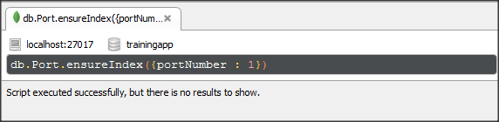Picture 1.1. Single field index – example 1
Other word, if we want to query on “interfaceType” of “typePort” field, we can create an index like:

Two above indexes are type of single field index.
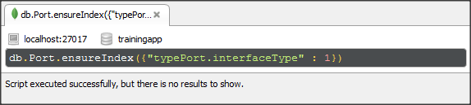Picture 1.2. Single field index – example 2

b. Compound fields indexes
Compound field indexes include data from more than one field of documents in a collection. For example, use above sample document for the Port collection. If we want to find documents base on both “portNumber” field and “createDate” field, we can create a compound index like:
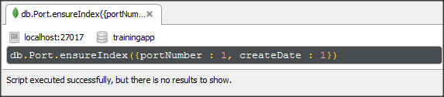Picture 1.3. Compound fields index
* portNumber is called Index prefix of above compound index.
* Restriction of Compound Index:
- Index can apply for query: by portNumber field, or both portNumber field and createDate
- Index can apply for query: by only createDate
It mean compound indexes only can fulfill queries which include Index prefix.

c. Multikey indexes
Multikey indexes is a type of index use for index a field which hold an array value. It references an array and records a match if query includes any value in the array. When we use multikey indexes, MongoDB will add index items for each item in the array. See “ports” filed of follow document :
{
"_id": 1,
"_class": "training.model.Device",
"name": "Switch1",
"ipAddress": "10.1.1.1",
"status": "Active",
"ports": [
1,
2,
3,
4
],
"createDate": new Date(1402977732000) /*6/17/2014, 11:02:12 AM*/,
"modifiedDate": new Date(1402977732000) /*6/17/2014, 11:02:12 AM*/,
"description": "This is a switch. For test."
}
We can create a multikey index like:
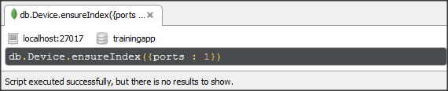Picture 1.4. Multikey index

d.Text indexes
Text indexes support search with string content in documents. We can create text index for a specific field or all field that contain string content.
- Create text index for “description” field of above document:
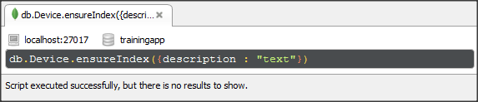Picture 1.5. Text index with one field
- Create text index for all fields: use wildcard specifier ($**)
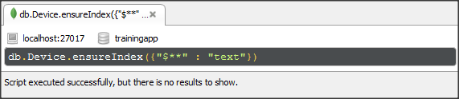Picture 1.6. Text index with all fields
* To create text indexes, we need enable text search when start MongoDB by: --setParameter textSearchEnabled=true

e. Hash indexes
Hash index maintain entries with hash of values of the hashed indexed field. The hash function collapse sub-documents and computers the hash for entire value but does not support multikey indexes. MongoDB can use hash index to support equality queries but not range queries. Create a hash index like following:
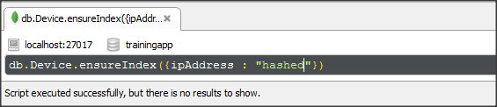Picture 1.7. Hash index

g. Geospatial Indexes and Queries
Geospatial Indexes and Queries support location-base searches on data that is stored as either GeoJSON objects or legacy coordinate pairs. There are 2 main types of Geospatial indexes which you can build. These are 2dsphere and 2d.
The kind of index which are chose depend on storing your location data.
- To calculate geometry over an Earth-like sphere, store your location data on a spherical surface and use 2dsphere index. For example, see sample document below:
{
"_id": {
"$oid": "53ccd72af2abd7d71dce1ec7"
},
"name": "Lab4",
"loc": {
"type": "Point",
"coordinates": [
100,
10
]
}
}
We create 2dsphere index like:
- To calculate distances on a Euclidean plane, store your location data as legacy coordinate pairs and use a 2d index. For example, see sample document below:
{
"_id": {
"$oid": "53ccd72af2abd7d71dce1ec7"
},
"name": "Lab4",
"loc": [
40.731,
-73.999
]
}
We create 2d index like:

1.1.2. Index properties

a. TTL indexes
TTL (Time to live) indexes is used for TTL collections, which expire data after a period of time. It’s a special indexes that MongoDB can use to automatically remove documents after a certain amount of time. This is ideal for some types of information like machine generated event data, logs, and session information that only need to persist in a database for a limited amount of time. See sample document for a Log collection follow:
{
"_id": {
"$oid": "53bf87a8ca0f8ec25b982bbc"
},
"createAt": new Date(1405059897000) /*7/11/2014, 1:24:57 PM*/,
"logType": "Fail",
"logMessage": "Switch up fail"
}
We can create TTL index like below:
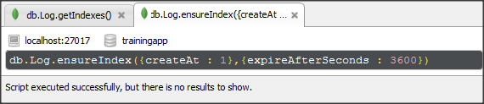Picture 1.8. TTL index
New document is created in Log collection. And this documents in Log collection will be deleted by automatic after 1h.

b. Unique Indexes
Unique indexes cause MongoDB to reject all documents that contain a duplicate value for the indexes field. Default index which is create from _id field is a unique indexes. To create an unique index we need to set unique property is true.
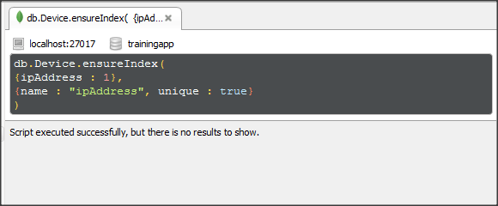Picture 1.9. Unique index
* If there are duplicated values of indexed field in database. We can't create the unique index for that field.

c. Sparse Indexes
Sparse indexes skip over documents which don’t include indexed field. It's useful when we have large of number documents and small percent of them contain indexed field. It help query operation will be faster much.
To create a sparse index we use command like:
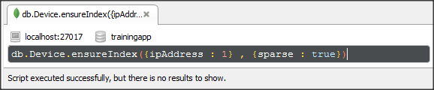Picture 1.10. Sparse index

1.1.3 Index Intersection
See sample document for collection Device again:
{
"_id": 1,
"_class": "training.model.Device",
"name": "Switch1",
"ipAddress": "10.1.1.1",
"status": "Active",
"ports": [
1,
2,
3,
4
],
"createDate": new Date(1402977732000) /*6/17/2014, 11:02:12 AM*/,
"modifiedDate": new Date(1402977732000) /*6/17/2014, 11:02:12 AM*/,
"description": "This is a switch. For test."
}
We create two indexes for this collection like:
Then we query like:

Both “status” index and “ipAddress” index are used to fulfill the query.

* Difference between Index Intersection and Compound Index.
Index Intersection | Compound Index
- Intersection of 2 indexes which can be single index, compound index, or others indexes.  - Can’t not support queries when don’t have proper existing indexes. | - Include 2 or many fields in document.  - Can’t support queries which don’t include Index prefix.

See below example:
There are a compound index:
It can support query like:
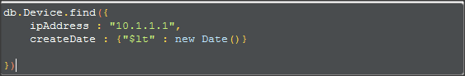

It can’t support query like:
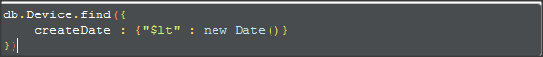

because the query doesn’t include index prefix.
But if we have 2 separated indexes like following, the index intersection will support for both queries above.

1.2. Management
To example for indexes management, use follow collection like below.
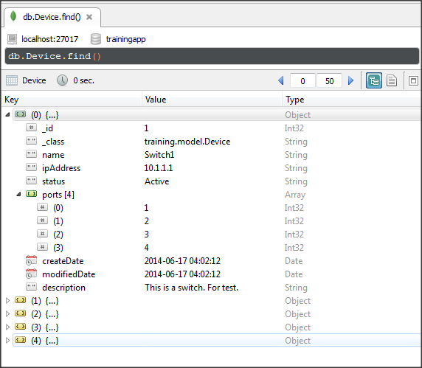Picture 1.11. Device collection

1.2.1. Create indexes
Syntax:
db.collectionName.ensureIndex({field or set of fields},[{index properties}])

If we have to search devices by ipAddress many times, we can create an index from ipAddress field. And ipAddress is unique field so we can set unique property for this index.
In Robomongo, we use follow command:
Picture 1.12. Create ipAddress index
In MongoTemplate, we do:

Picture 1.13. Create ipAddress index in java

1.2.2. Get indexes of a collection
To see result of above example, we can use getIndexes() operation of MongoDB.
Syntax:
db.collectionName.getIndexes()
In Robomongo:
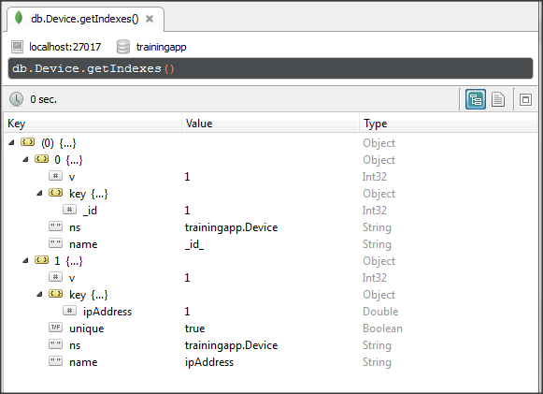Picture 1.14. Get indexes in database
Above result, Device collection has 2 indexes.
+ The first is default index for each collection which is created by MongoDB from _id field.
+ The second is ipAddress index which is created by our example.
In MongoTemplate, we do:
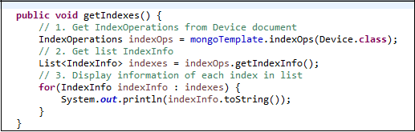Picture 1.15. Get indexes using java

1.2.3. Remove indexes:
Remove an index of a document:
Syntax:
db.collectionName.dropIndex({indexName})
Or
db.collectionName.dropIndex({field : value})
+ value: -1 or 1 depend on order of index when we created before.
Remove all indexes of a document:
Syntax:
db.collectionName.dropIndexes()

In Robomongo, we use follow command:
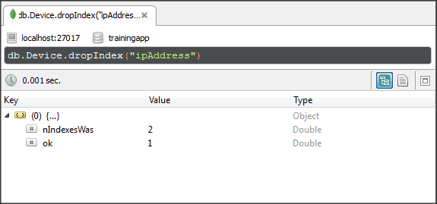Picture 1.16. Drop indexes
In MongoTemplate, we do:
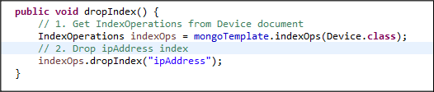Picture 1.17. Drop indexes using java

1.2.4. Rebuild an index
As you perform inserts, updates and deletes, your indexes will become fragmented both internally and externally. Internal fragmentation is you have a high percentage of free space on your index pages, meaning that database needs to read more pages when scanning the index. External fragmentation is when the pages of the index are not in order any more, so database has to do more work, especially in IO terms to read the index.
So we need rebuild index. MongoDB provide we an operation is:
db.collectionName.reIndex()

1.2.5. Speed comparison of query with indexes and not
We will use Log collection with 3000 documents for testing speed of query when indexes is set up and not. See Log collection .
Using java codes to insert documents:
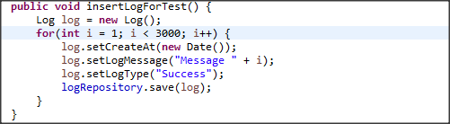Picture 1.18. Insert documents into Log collection
Situation: Find switches which are created after "2014-07-21" . We will choose "createAt" field to ensure index. Compare time to complete find query.

Using following codes block to check in java:
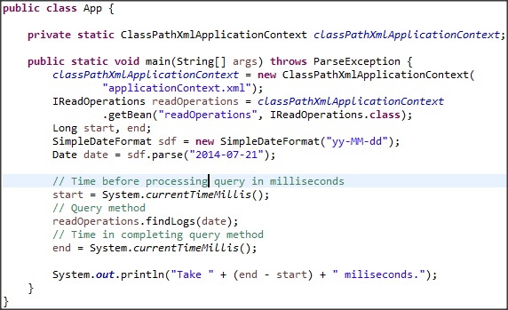Picture 1.19. Java codes block for test speed of index
findLogs method is:
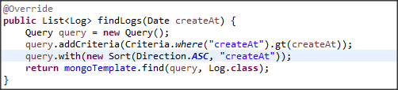Picture 1.20. Get Log documents in java

See explain() of query before set up index.
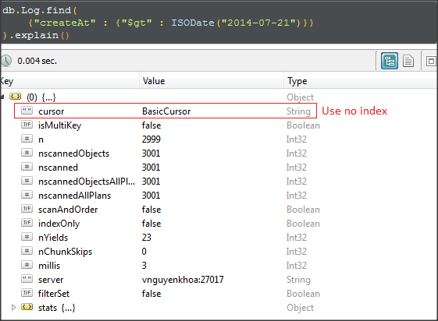Picture 1.21. Speed comperison without index– explain query
Time to process query:
Then we set up index:
See explain() of query after set up index.
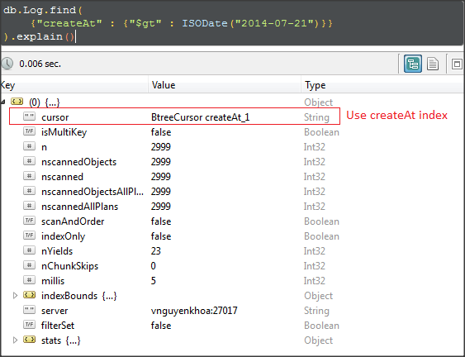Picture 1.22. Speed comperison with index– explain query
Time to process query:

1.2.6. Indexed annotation (@Indexed)

a. Indexed annotation
Indexed annotation is a type of mapping annotation in Spring mongo data. It's applied at the field level to describe how to index the field.
It also provide us options to build other types of indexes as the following:
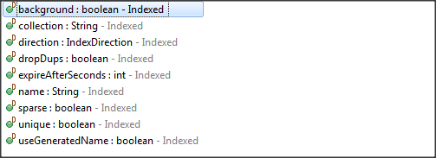

How to Indexed annotation work:
- Check existence of indexes which correspond to indexed field.
- If those indexes are not exists, they will be created.
- The application will process other operations.
Example: Index two field “name” and “ipAddressInfo” with unique type. Then use repository to insert documents that is exists in database. See how to indexed annotation work. See Switch model class is used for mapping with Switch collection like the following:
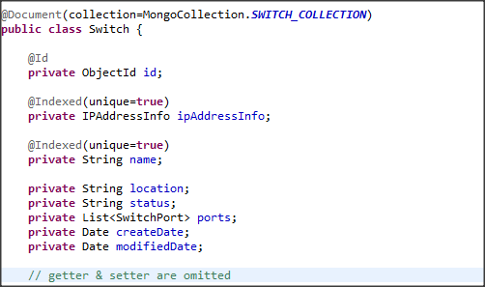Picture 1.23. Switch model class
Switch collection before insert new documents:
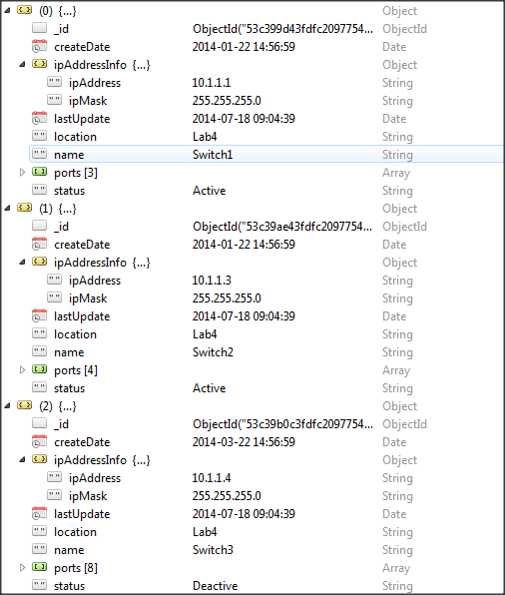Picture 1.24. Sample Switch collection

All indexes of this collection:
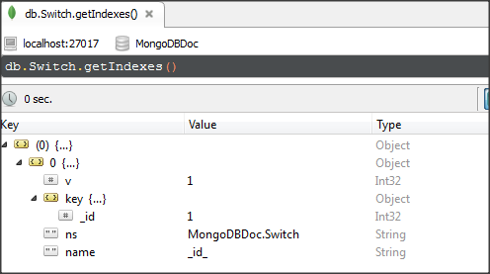Picture 1.25. All index of Switch collection
* Insert a document which has field “name” which is exists
Java codes:
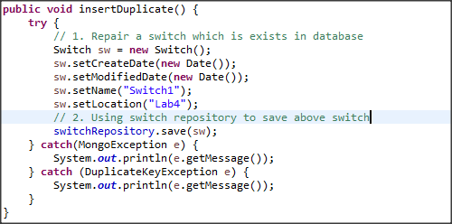Picture 1.25. All index of Switch collection

See all indexes of collection again:
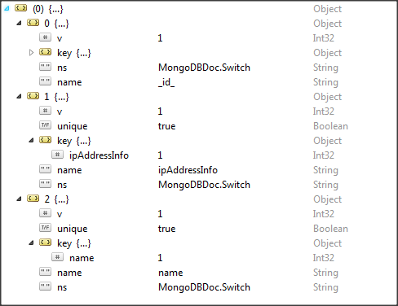Picture 1.26. All index of Switch collection

But there is no new document in database and the application occur error like:
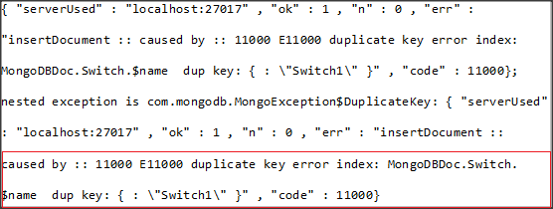
The application occur error because the unique indexes of “name” field is added. So this unique indexes doesn't allow new document with name “Switch1” is inserted.

* Insert a document which has duplicated field “ipAddress”
Java codes:
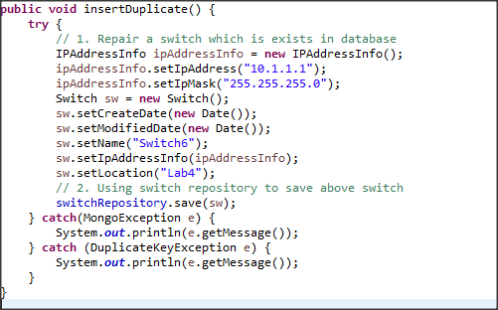Picture 1.27. Example use model class in java 2

The application occur error like:
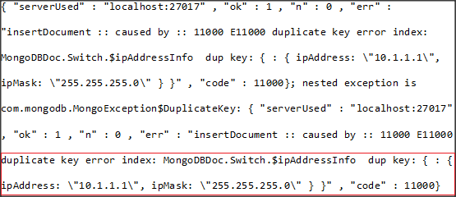
* Notice that there is an excepted case with save() method of repository. If we insert new document with _id field which is exists in database. The exists document will be updated instead of inserting new document.

b. Restriction
There are some cases which we can't create index by using indexed annotation.
Case 1: There is an exists index of indexed field in database.
See Switch model class again:
Picture 1.28. Switch model class
If the database has 1 index of field “name” like:
{
"v": 1,
"key": {
"name": 1
},
"name": "name",
"ns": "MongoDBDoc.Switch"
}
When the application use Swich model is executed, there is an error like:
The application occur error because there is an not unique index of field “name” with. So driver can't add unique index for field “name”. It mean the @Indexed can't help application override exists index in database.
Case 2: Collection include documents which have duplicated values at index field.
See sample documents in Switch collection:
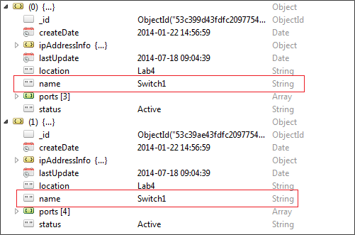Picture 1.29. Sample documents in Switch collection
Executing the application which use Switch model, there is error like:
The application occur error because there are duplicated values of field “name” in database (see Unique indexes section for more detail).

1.2.7. CompoundIndex annotation (@CompoundIndex)
CompoundIndex annotation is a type of mapping annotation in Spring mongo data. It's applied at the document level to describe how to create compound index. See Switch model class which is used for mapping Switch collection like following:
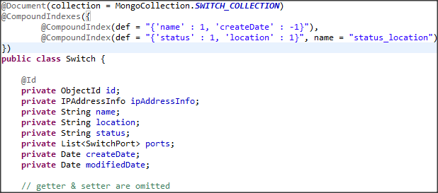Picture 1.30. Switch model class
- All compound indexes are defined in @CompoundIndexes.
- Every compound index include a required option is def to describe what fields is used for indexing.
- Beside that, there are other options to build other types of compound index like:
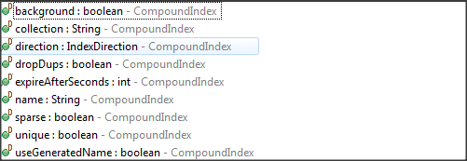

Example: Creating 2 compound indexes by using annotation (see above model):
- Compound index of two field: name and createDate.
- Compound index of two field: status and location. And name is: status_location.
The result:
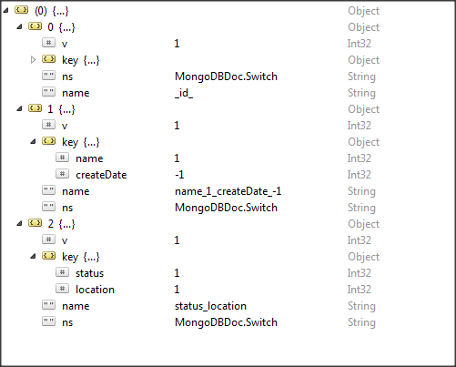

QUERY OPERATION

Read operations
Syntax:
db.collectionName.find([{query criteria}], [{projection}]).cursor-modifier()
- collectionName: include needed documents.
- query criteria: include conditions to find documents.
- projection: specify a list of fields to return or a list of field to exclude.
- cursor-modifier: modify result such as: limit, skip, sort, order.
There is a special case of find() method which return a single document:
db.collectionName.findOne([{query criteria}], [{projection}])

There are some types of read operations like the following:
No | Type | Description
1 | Get all documents | - Command: db.collection.find().  - Get all documents in the collection.
2 | Get list of documents with equality conditions. | - Command: db.collection.find(<query criteria>)  - Query criteria: {<field> : <value>}  - Get list of documents contain <field> with specified <value>.
3 | Get list of documents with conditions using query operators. | - Command: db.collection.find(<query criteria>).  - Query criteria: detail in the following.  - Get list of document contain <field> with: specifed value, range values, type, etc.
4 | Get list of documents with conditions which include embedded documents. | - Command: db.collection.find(<query criteria>).  - Query criteria: {<field> : <embedded document>}, or {<field> : <field of embedded document>}.  - Get list of document contain <field> exact match embedded document or exact match within fields of embedded document.
5 | Get list of documents with conditions which include arrays. | - Command: db.collection.find(<query criteria>).  - Query criteria: {<field> : <an array>}, {<field> : <an element>} or {<field> : <specified element>}.  - Get list of document contain <field> exact match an array or specified values in the array.
6 | Get list of documents with specified fields. | - Command: db.collection.find(<query criteria>, <projection>).  - Query criteria: like from No1 to No5.  - Projection: include fields [{<field> : 1}] or exclude fields [{<fields> : 0}]  - Get list of documents which only include specified fields.
7 | Get list of documents with cursor modifiers. | - Command: db.collection.find(<query criteria>, <projection>).cursor-modifier().  - Query criteria: like from No1 to No5.  - Projection: like No6.  - Cursor modifier: sort(), limit(), skip(), order().  - Support for sorting, paging, increase performance of read operations.
Table 2.1. Types of read operations.

In the following, we will build query conditions to get necessary documents by combine query operators. But how to combine operators is various and depend on the application requirements. See full operators in Query Operators.
Using collection with documents that contain fields similar to the following (Switch collection):
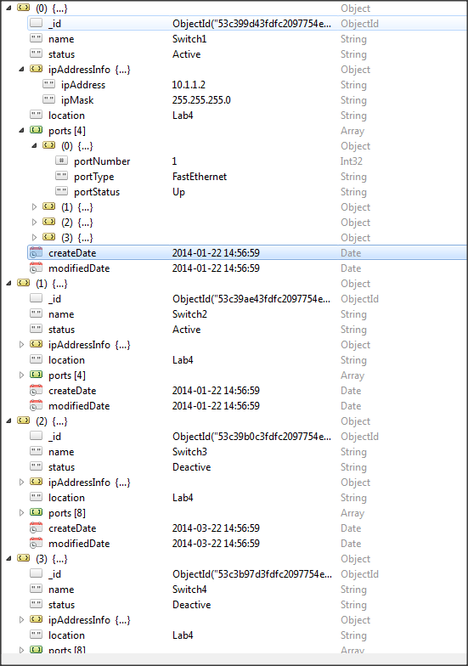Picture 2.1. Switch collection

Using operator $lt
Format: {field : {$lt : query-value}}
Description: Matches values that are less than query-value.
Example: Find switches which are created before 01-02-2014.
In Robomongo:
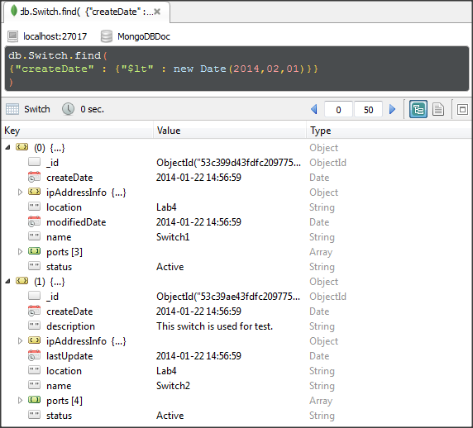Picture 2.2. Operator $lt in Robomongo

Using MongoTemplate:
Picture 2.3. Operator $lt using java

Using Repository:
First, we need create method in our SwitchRepository:
Picture 2.4. Method using operator $lt in Switch repository
Then use in application:
Picture 2.5. Using repository in application

Using operator $gt
Format: {field : {$gt : query-value}}
Description: Matches values that are great than query-value.
Example: Find switches which is created after 01-02-2014.
In Robomongo:
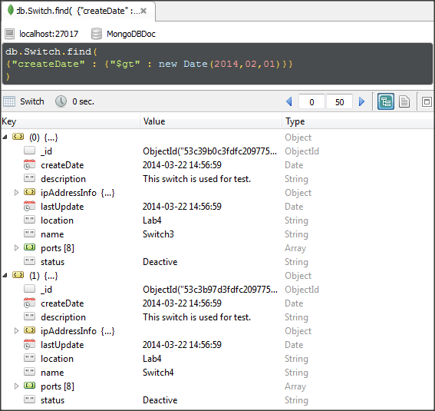Picture 2.6. Operator $gt in Robomongo

Using MongoTemplate:
Picture 2.7. Operator $lt using java
Using Repository:
First, we need create method in our SwitchRepository:
Picture 2.8. Method using operator $gt in Switch repository

Then use in application:
Picture 2.9. Using repository in application

Using operator $lte
Format: {field : {$lte : query-value}}
Description: Matches values that are less than or equal query-value.
Example: Find switches which are created on 22-01-2014 or before.
In Robomongo:
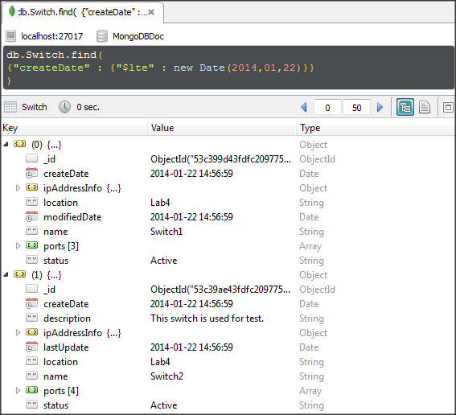Picture 2.10. Operator $lte in Robomongo

Using MongoTemplate:
Picture 2.11. Operator $lte using java
Using Repository:
First, we need create method in our SwitchRepository:
Picture 2.12. Method using operator $lte in Switch repository

Then use in application:
Picture 2.13. Using repository in application

Using operator $gte
Format: {field : {$gte : query-value}}
Description: Matches values that are great than or equal query-value.
Example: Find switches which are created on 22-03-2014 or after.
In Robomongo:
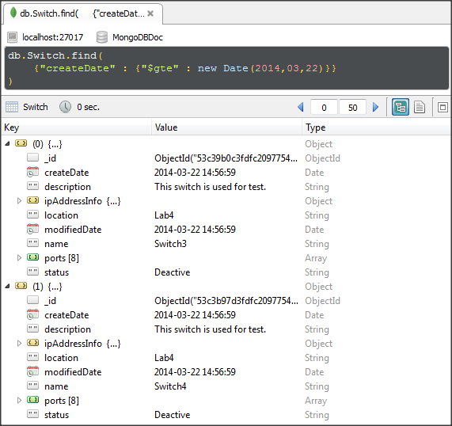Picture 2.14. Operator $gte in Robomongo

Using MongoTemplate:
Picture 2.15. Operator $gte using java
Using Repository:
First, we need create method in our SwitchRepository:
Picture 2.16. Method using operator $gte in Switch repository

Then use in application:
Picture 2.17. Using repository in application

Using operator $in
Format: {field : {$in : array}
Description: Matches values that are one of elements in array.
Example: Find switches which have ip address is 10.1.1.1 or 10.1.1.2
In Robomongo:
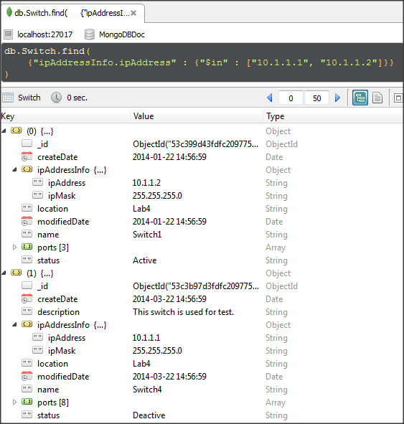Picture 2.18. Operator $in Robomongo

Using MongoTemplate:
Picture 2.19. Operator $in using java
Using Repository:
First, we need create method in our SwitchRepository:
Picture 2.20. Method using operator $in in Switch repository

Then use in application:
Picture 2.21. Using repository in application

Using operator $nin
Format: {field : {$nin : array}
Description: Matches values that are not one of elements in array.
Example: Find switches which have ip address is 10.1.1.1 or 10.1.1.2
In Robomongo:
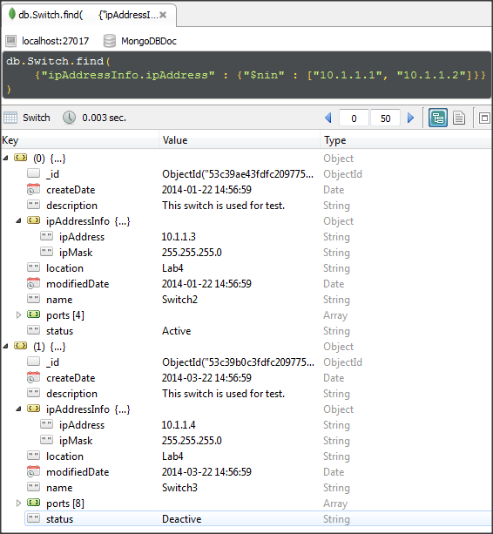Picture 2.22. Operator $nin in Robomongo

Using MongoTemplate:
Picture 2.23. Operator $nin using java
Using Repository:
First, we need create method in our SwitchRepository:
Picture 2.24. Method using operator $nin in Switch repository

Then use in application:
Picture 2.25. Using repository in application

Using operator $ne
Format: {field : {$ne : query-value}
Description: Matches values that are not equal query-value.
Example: Find switches which are not active.
In Robomongo:
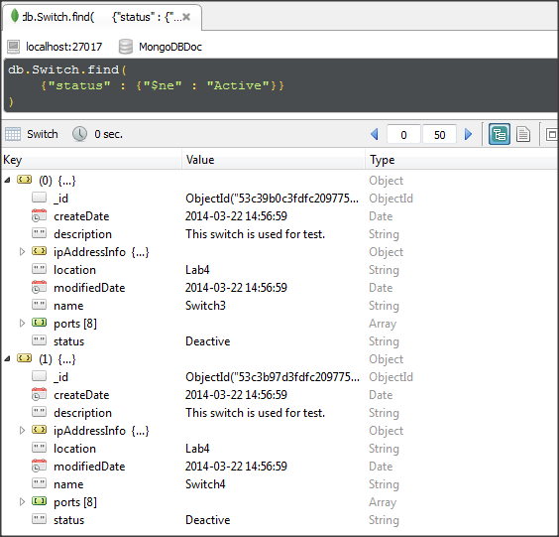Picture 2.26. Operator $ne in Robomongo

Using MongoTemplate:
Picture 2.27. Operator $ne using java
Using Repository:
First, we need create method in our SwitchRepository:
Picture 2.28. Method using operator $ne in Switch repository

Then use in application:
Picture 2.29. Using repository in application

Using operator $or
Format: {$or : [criteria 1, criteria 2, …, criteria n]}
Description: Matches values that match least 1 criteria.
Example: Find switches which have ip address is either 10.1.1.1 or 10.1.1.3.
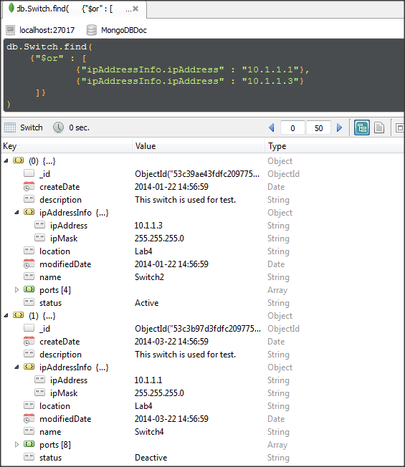Picture 2.30. Operator $or in Robomongo

Using MongoTemplate:
Picture 2.31. Operator $or using java
Using Repository:
First, we need create method in our SwitchRepository:
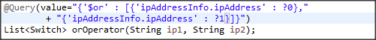Picture 2.32. Method using operator $or in Switch repository

Then use in application:
Picture 2.33. Using repository in application

Using operator $and
Format: {$and : [criteria 1, criteria 2, …, criteria n]}
Description: Matches values that match all criteria in criteria array.
Example: Find switches which are active and are in Lab4.
In Robomongo:
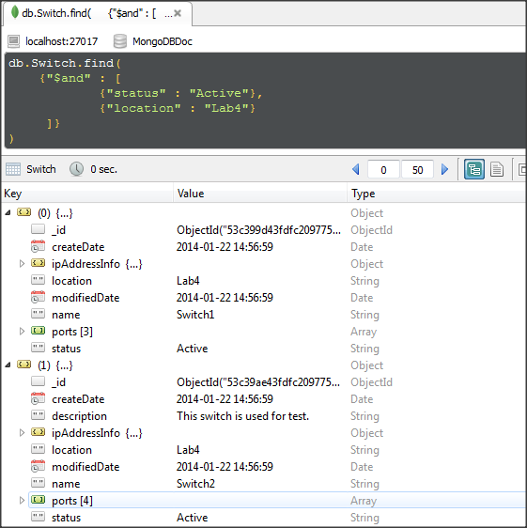Picture 2.34. Operator $and in Robomongo

Using MongoTemplate:
Picture 2.35. Operator $and using java
Using Repository:
First, we need create method in our SwitchRepository:
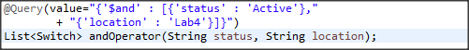Picture 2.36. Method using operator $and in Switch repository

Then use in application:
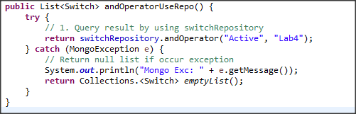Picture 2.37. Using repository in application

Using operator $not
Format: {field : {$not : operator-expression}}
Description: Matches values that do not match operator-expression.
Example: Find switches which have ip address is not 10.1.1.1 or 10.1.1.3.
In Robomongo:
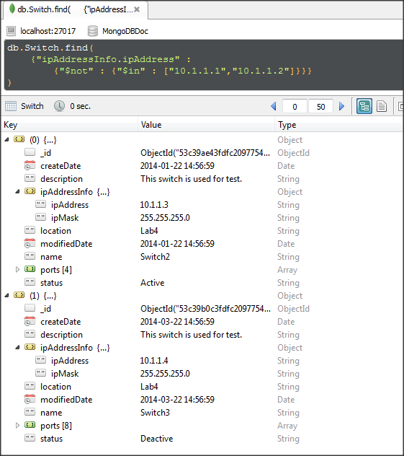Picture 2.38. Operator $not in Robomongo

Using Mongotemplate:
Picture 2.39. Operator $not using java
Using Repository:
First, we need create method in our SwitchRepository:
Picture 2.40. Method using operator $not in Switch repository

Then use in application:
Picture 2.41. Using repository in application

Using operator $nor
Format: {$nor : {criteria 1, criteria 2, . . . , criteria n}}
Description: Matches values that do not match all criteria in criteria array.
Example: Find switches which have ip address is not 10.1.1.1 or 10.1.1.3.
In Robomongo:
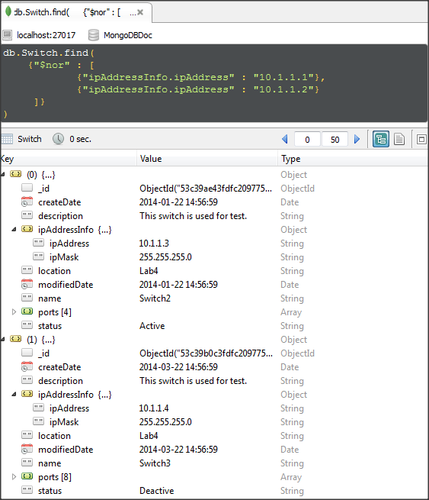Picture 2.42. Operator $nor in Robomongo

Using MongoTemplate:
Picture 2.43. Operator $nor using java
Using Repository:
First, we need create method in our SwitchRepository:
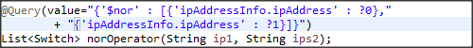Picture 2.44. Method using operator $nor in Switch repository

Then use in application:
Picture 2.45. Using repository in application

Using operator $exists
Format: {field : {$exists : boolean-value}}
Description: Matches values that have specified field.
Example: Find switches which have field “ipMask” in sub-document ipAddressInfo.
In Robomongo:
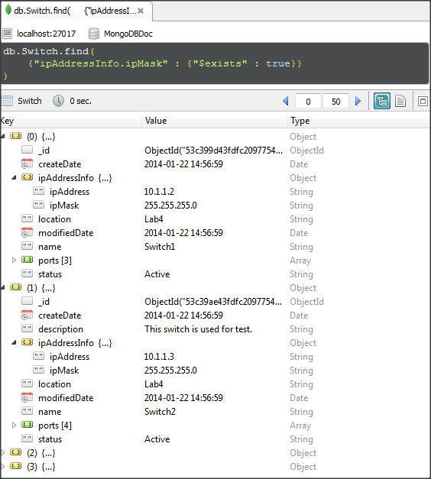Picture 2.46. Operator $exists in Robomongo
Using MongoTemplate:
Picture 2.47. Operator $exists using java
Using Repository:
First, we need create method in our SwitchRepository:
Picture 2.48. Method using operator $exists in Switch repository

Then use in application:
Picture 2.49. Using repository in application

Using operator $type
Format: {field : {$type : typeCode}}
Description: Matches values that have type of field is equal typeCode. (See full typeCode in Types of data).
Example: Find switches which have field createDate is date type.
In Robomongo:
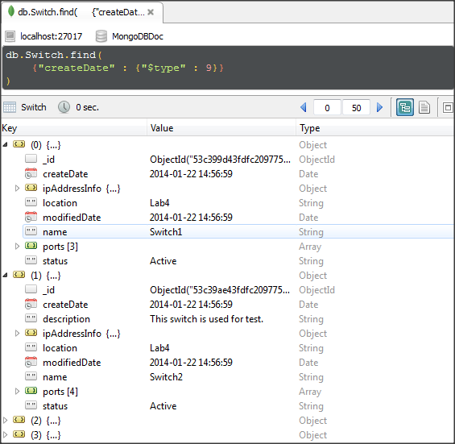Picture 2.50. Operator $type in Robomongo
Using MongoTemplate:
Picture 2.51. Operator $type using java
Using Repository:
First, we need create method in our SwitchRepository:
Picture 2.52. Method using operator $type in Switch repository

Then use in application:
Picture 2.53. Using repository in application

Using operator $size
Format: {field : {$size : numberOfElement}}
Description: Matches values have size of field is equal numberOfElement.
Example: Find switches which have 3 ports.
In Robomongo:
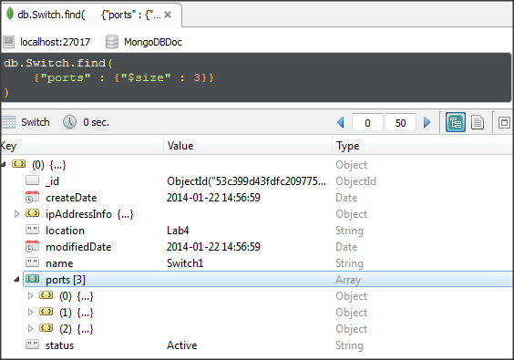Picture 2.54. Operator $size in Robomongo

Using MongoTemplate:
Picture 2.55. Operator $size using java
Using Repository:
First, we need create method in our SwitchRepository:
Picture 2.56. Method using operator $size in Switch repository

Then use in application:
Picture 2.57. Using repository in application

Using operator $regex
Format: {field : {$regex : pattern}}
Description: Matches values match with pattern (MongoDB uses Perl compatible regular expressions).
Example: Find switches which have name is S*[2-4].
In Robomongo:
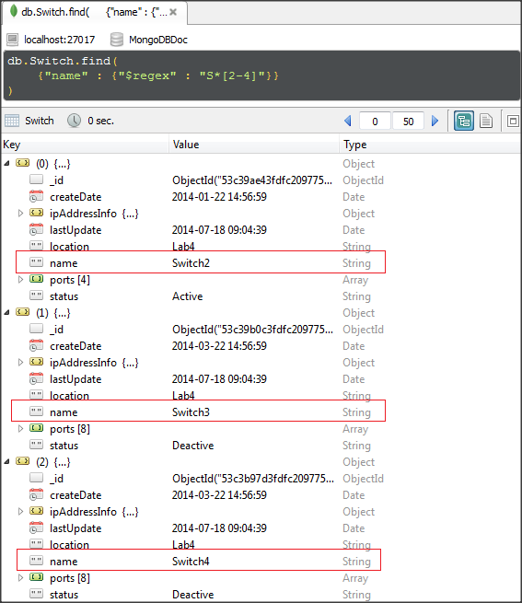Picture 2.58. Operator $regex in MongoTemplate

Using MongoTemplate:
Picture 2.59. Operator $regex using java
Using Repository:
First, we need create method in our SwitchRepository:
Picture 2.60. Method using operator $regex in Switch repository

Then use in application:
Picture 2.61. Using repository in application

Combine read operators
To get necessary documents, we usually need build complex query criteria. This section will show how to build complex query criteria by using combine operators.

Using operators $and, $or, $in, $size, $lt
We need get switches have:
- Status is active.
- Have 4 ports.
- IP address is: 10.1.1.2 or 10.1.1.3
- Create before Feb 2014
So we can build a query criteria like:
- {"status" : "Active"}
- {"ports" : {"$size" : 4}}
- {"ipAddressInfo.ipAddress" : {"$in" : ["10.1.1.2", "10.1.1.3"]}}
- {"createDate" : {"$lt" : new Date(2014,02,01)}}
In above criteria, you can change
{"ipAddressInfo.ipAddress" : {"$in" : ["10.1.1.2", "10.1.1.3"]}}
to {"$or" : [
{"ipAddressInfo.ipAddress" : "10.1.1.1"},
{"ipAddressInfo.ipAddress" : "10.1.1.2"}
]}

In Robomongo:
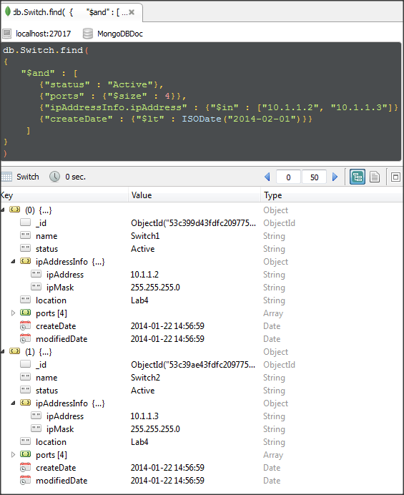Picture 2.62. Combine operators – example 1.

Use MongoTemplate:
Picture 2.63. Combine operators using java – example 1
Use Repository:
- First, we need create method in our SwitchRepository:
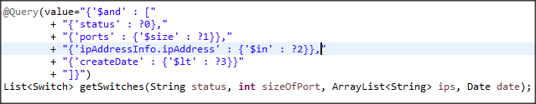Picture 2.63. Combine operators using repository - example 1
- Then use in application:
Picture 2.65. Using repository in application

Using operators $and, $lt, $ne, $size, $exists, $type
We need get switches with:
- Have 8 ports.
- IP address is not “10.1.1.1”.
- Exist createDate and modifiedDate fields.
- And type of them are date type.
We can build a query criteria like:
- {"ports" : {"$size" : 8}}
- {"ipAddressInfo.ipAddress" : {"$ne" : "10.1.1.1"}}
- {"createDate" : {"$exists" : true}}
{"modifiedDate" : {"$exists" : true}}
- {"createDate" : {"$type" : 9}}
{"modifiedDate" : {"$type" : 9}}
In Robomongo:
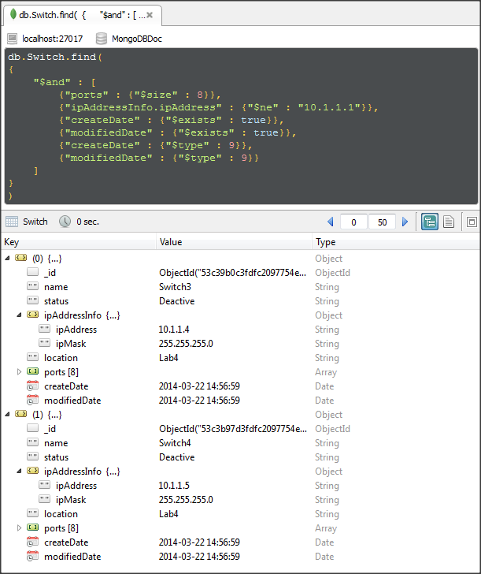Picture 2.66. Combine operators – example 2

Use MongoTemplate:
Picture 2.67. Combine operators using java – example 2
Use Repository:
First, we need create method in our SwitchRepository:
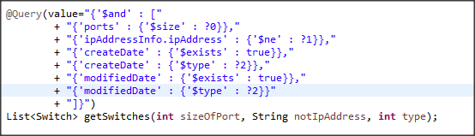Picture 2.68. Combine operators using repository - example 2
Then use in application:
Picture 2.69. Using repository in application

Modifies operations
In MongoDB, both update() and save() modify existing documents in a collection. Update() provides additional control over the modification. For example, you can modify existing data or modify a group of documents that match a query with Update(). So we will practice with update() operation.
See full operators in Update Operators.
Syntax of update():
db.collectionName.update(<query>, <update>, <optional>)
Syntax of save():
db.collectionName.save(<document>)

Using operators $rename
Format: {$rename : {oldName, newName}}
Description: Change name of field to new name.
Example: Rename modifiedDate field to lastUpdate for all Switches.
Before update:
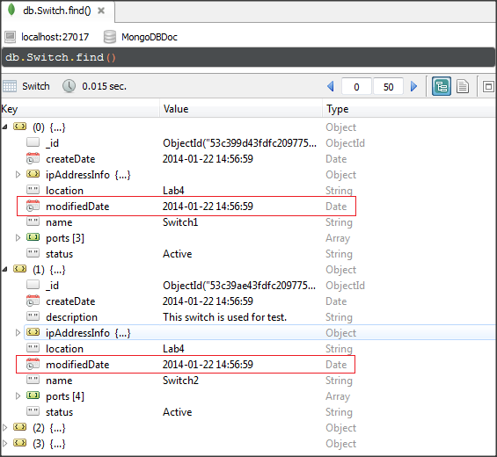Picture 2.70. Operator $rename – before update
Command to update:
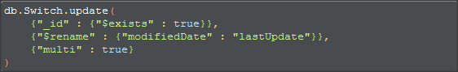
The result:
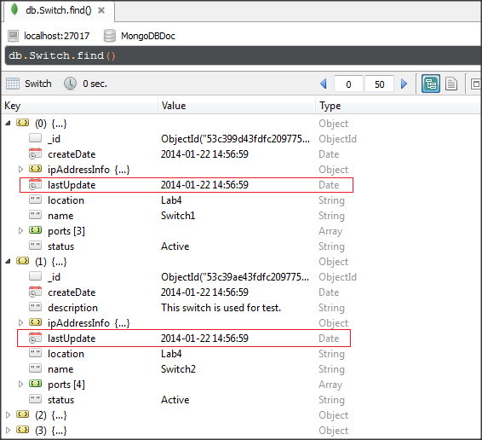Picture 2.71. Operator $rename – result of update

Using MongoTemplate:
Picture 2.72. Operator $rename using java

Using operators $set
Format: {$set : {field : update-value}}
Description: Change the value of field or create new field with update-value.
Example: Add “switchTable” field for Switche1 like:
switchTable : [
{port : 1, station : “Mac A”, vlan : 100},
{port : 2, station : “Mac B”, vlan : 100},
{port : 3, station : “Mac C”, vlan : 200},
{port : 4, station : “Mac D”, vlan : 200}
]

Before update:
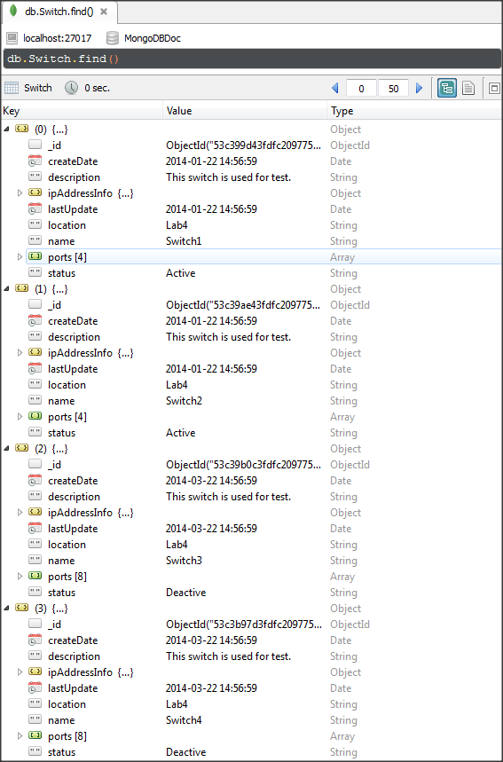Picture 2.73. Operator $set – before update without switchTable field

Command to update:
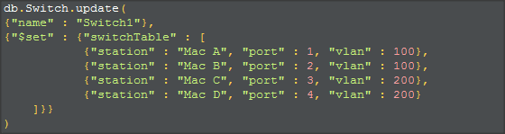
The result:
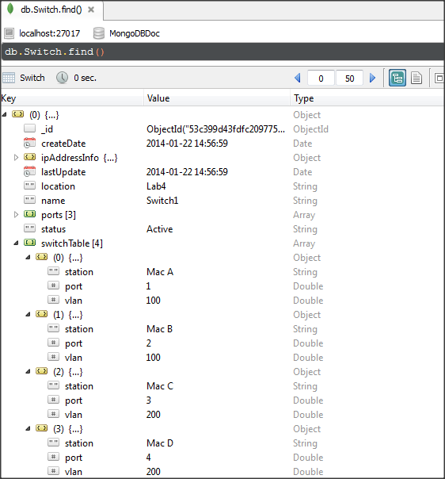Picture 2.74. Operator $set – result of update with switchTable field

Using MongoTemplate:
Picture 2.75. Operator $set using java

Using operators $unset
Format: {$unset : {field : 1}}
Description: Remove specified field in documents. Number 1 is usually used in $unset operator. But it can others value like: “”, . . . .
Example: Remove “description” field in all switches.
Before update:
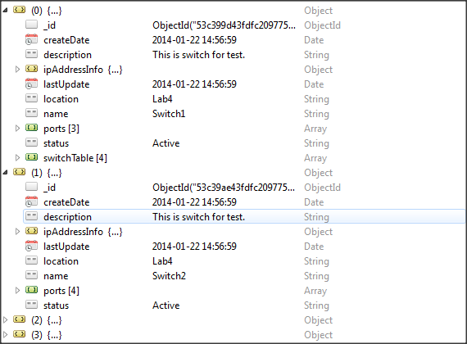Picture 2.76. Operator $unset – before update with description field

Command to update:
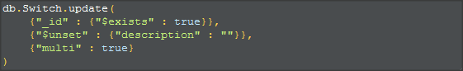
The result:
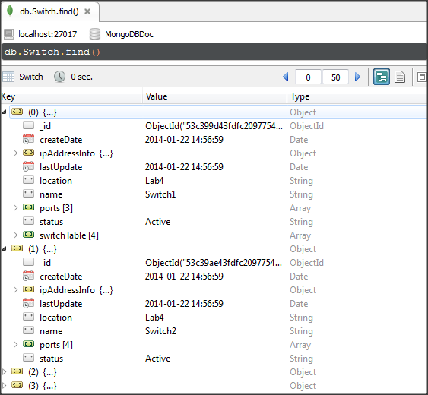Picture 2.77. Operator $unset – result of update without description field

Using MongoTemplate:
Picture 2.78. Operator $unset using java

Using operators $inc
Format: {$inc : {field : amount}}
Description: Increment the value of field by specified amount.
Example: Increase first element 's vlan to 200 in switchTable array of Switch1.
Before update:
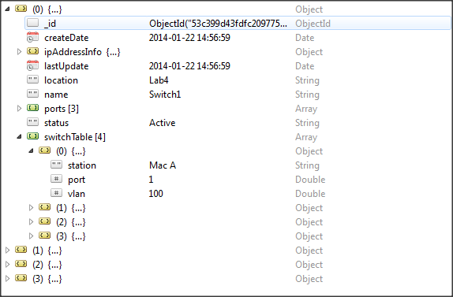Picture 2.79. Operator $inc – before update

Command to update:
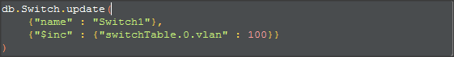
The result:
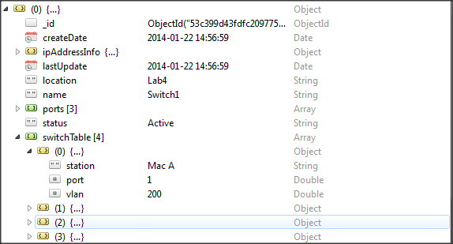Picture 2.80. Operator $inc – result of update
Using MongoTemplate:
Picture 2.81. Operator $inc – result of update

Using operators $mul
Format: {$mul : {field : amount}}
Description: Multiple the value of field by specified amount.
Example: Multiple second element 's vlan with 2 in switchTable array of Switch1.
Before update:
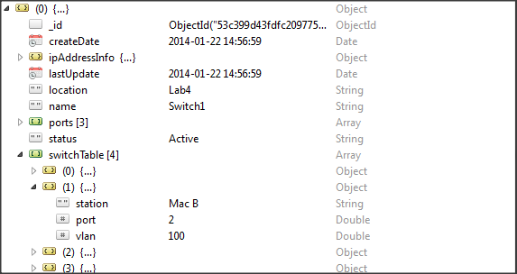Picture 2.82. Operator $mul – before update
Command to update:
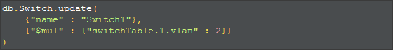
The result:
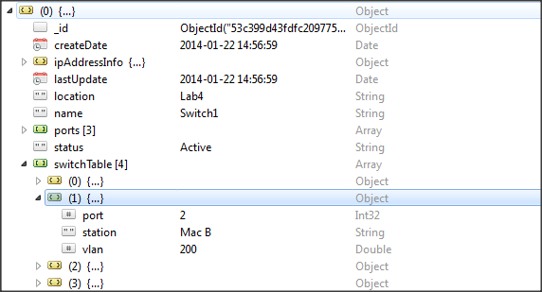Picture 2.83. Operator $mul – result of update

Using operators $min
Format: {$min : {field : new-value}}
Description: Only update field if new-value is less than old value of field.
Example: Change first element 's vlan from 200 to 100 in switchTable array of Switch1.
Before update:
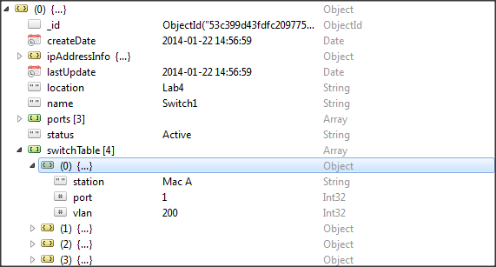Picture 2.84. Operator $min – before update
Command to update:
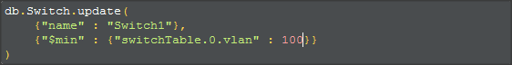
The result:
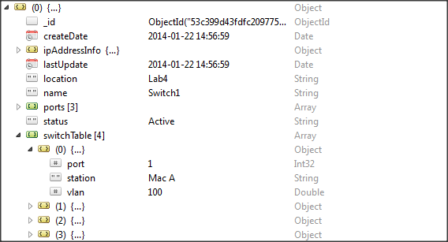Picture 2.85. Operator $min – result of update

Using operators $max
Format: {$max : {field : new-value}}
Description: Only update field if new-value is great than old value of field.
Example: Change first element 's vlan from 100 to 200 in switchTable array of Switch1.
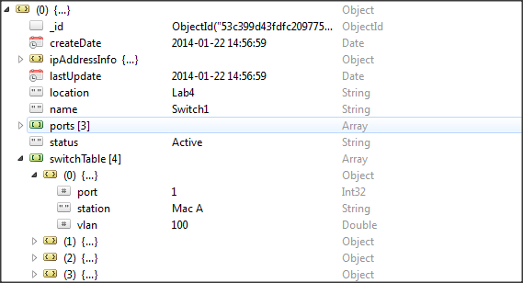Picture 2.86. Operator $max – before update
Before update:

Command to update:
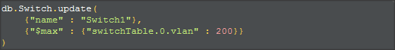
The result:
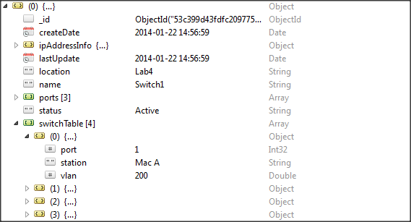Picture 2.87. Operator $max – result of update

Using operators $currentDate
Format: {$currentDate : {field : true or $type}}
Description: Set value of field is current date. Default type is “date” but we can set $type by lowercase “timestamp” or “date”.
Example: Set “lastUpdate” field of all switches are currentDate.

Before update:
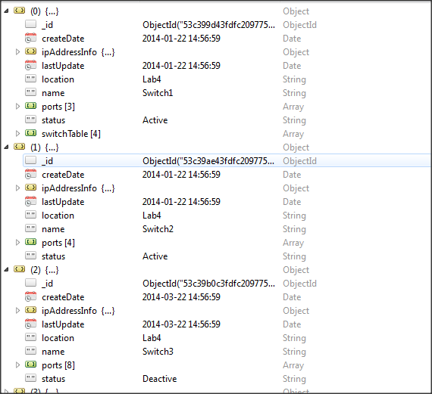Picture 2.88. Operator $currentDate – before update
Command to update:
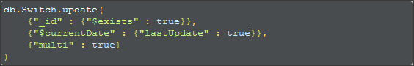
The result:
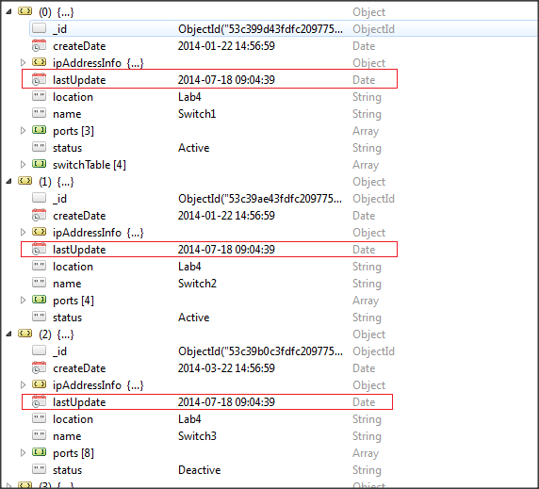Picture 2.89. Operator $currentDate – result of update

Using operators $pop
Format: {$pop : {field : boolean-value}}
Description: Remove first element of an array if boolean-value = -1 or remove last element of an array if boolean-value = 1.
Example: Remove first element in switchTable array of Switch1.
Before update:
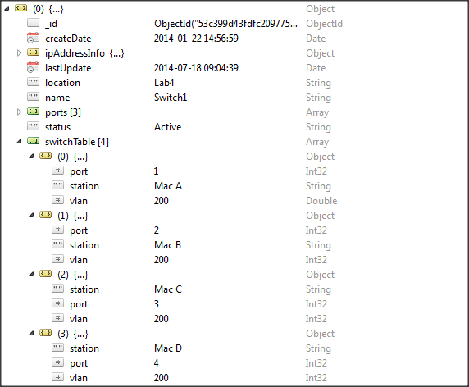Picture 2.90. Operator $pop – before update

Command to update:
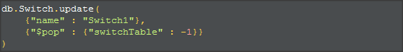
The result:
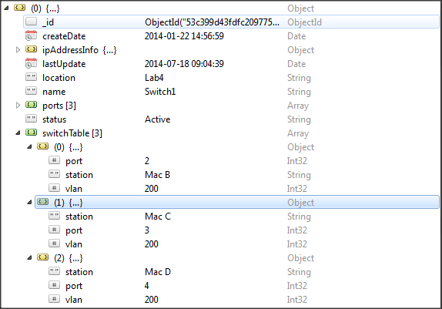Picture 2.91. Operator $pop – result of update

Using MongoTemplate:
Picture 2.92. Operator $pop using java

Using operators $pullAll
Format: {$pullAll : {field : value array}}
Description: Removes all matching values from an array.
Example: Remove 2 following elements in switchTable array of Switch1:
[ {port : 2, station : “Mac B”, vlan : 200} ,
{port : 3, station : “Mac C”, vlan : 200}]
Before update:
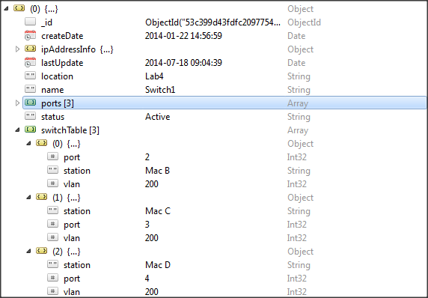Picture 2.93. Operator $pullAll – before update
Command to update:
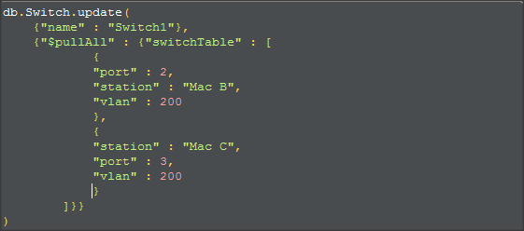
Result:
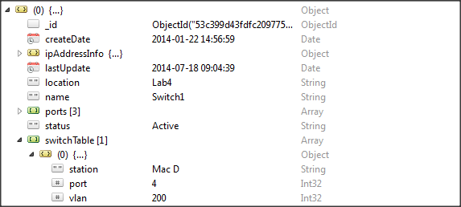Picture 2.94. Operator $pullAll – result of update
Using MongoTemplate:
Picture 2.95. Operator $pullAll using java

Using operators $push
Format: {$push : {field : value element}}
Description: Add an element into an array.
Example: Add following element to switchTable field of Switch1:
{port : 2, station : “Mac B”, vlan : 200}
Before update:
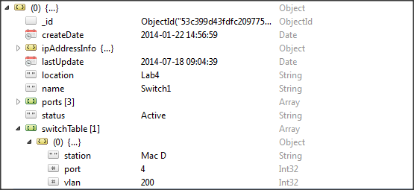Picture 2.96. Operator $push – before update
Command to update:
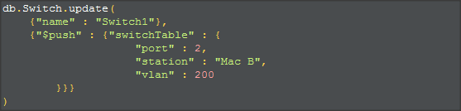
The result:
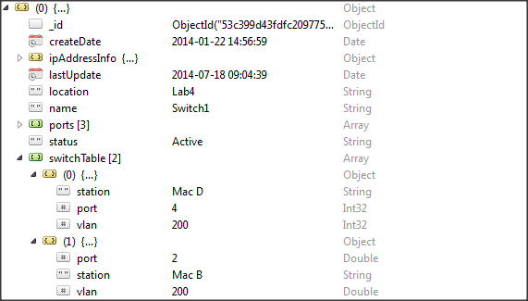Picture 2.97. Operator $push – result of update
Using MongoTemplate:
Picture 2.98. Operator $push using java

a. Modifier operator $each
Format: {$push : {field : {$each : array}}}
Description: Modified the $push operator to allow add multiple elements into field which is an array.

b. Modifier operator $slice
Format: {$push : {field : {$each : array, $slice : number}}}
Description: It must appear with the $each modifier. To limit number of elements in an array. If <number> is nagative, array contain only last <number> elements. If <number> is positive, array contain only first <number> elements.

c. Modifier operator $sort
Format: {$push : {field : {$each : array, $sort : {field : Order}}}}
Description: It must appear with the $each modifier. Reorder documents in array.

d. Modifier operator $position
Format: {$push : {field : {$each : array, $position : number}}}
Description: It must appear with the $each modifier. Specify the position in array to add elements. Default $push operation will add elements in last of array.

e. Example for using modifiers 1
Add following elements to switchTable field of Switch1:
{port : 1, station : “Mac A”, vlan : 200},
{port : 2, station : “Mac B”, vlan : 200},
{port : 3, station : “Mac C”, vlan : 200}
And order documents by ascending order of port field.
Before update:
Picture 2.99. Operator $push with modifiers operator – example 1

Command to update:
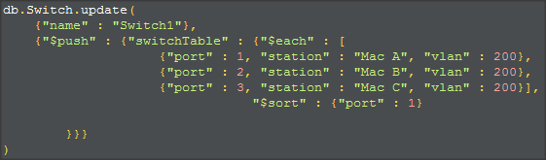

The result:
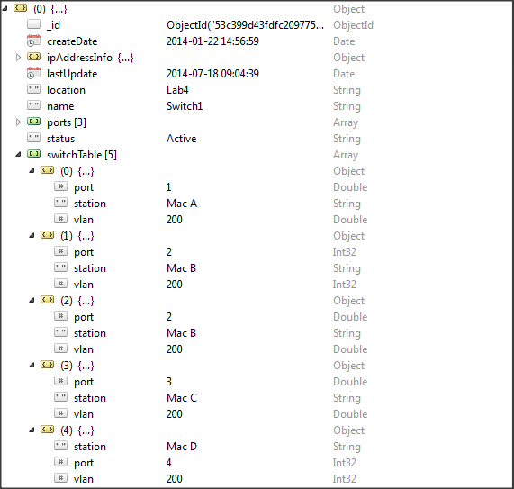Picture 2.100. Operator $push with modifiers – result of example 1

f. Example for using modifiers 2
Add following elements to switchTable field of Switch1:
{port : 1, station : “Mac A”, vlan : 200},
{port : 2, station : “Mac B”, vlan : 200},
{port : 3, station : “Mac C”, vlan : 200}
And limit 5 newest elements in array.
Before update:
Picture 2.42. Operator $push with modifiers operator – example 2

Command to update:
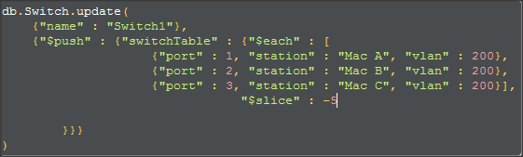
The result:
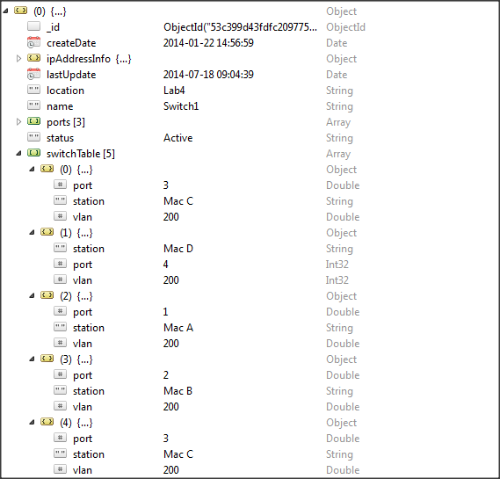Picture 2.101. Operator $push with modifiers – result of example 2

Using operators $pull
Format: {$pull : {field : operation-expression}}
Description: Remove elements in array that match operation-expression.
Example: Remove elements in switchTable array of Switch1 that have vlan is equal 200.
Before update:
Picture 2.102. Operator $pull – before update
Command to update:
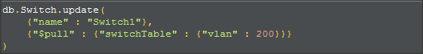
The result:
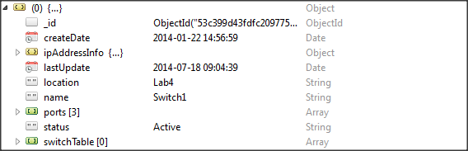Picture 2.103. Operator $pull – result of update
Using MongoTemplate:
Picture 2.104. Operator $pull using java

Using operators $addToSet
Format: {$addToSet : {field : value element}}
Description: Add an element into an array. It like $push operator but it only use for adding element which is not exist in array.
Example: Add following elements to switchTable field of Switch1:
{port : 2, station : “Mac B”, vlan : 200},
Before update:
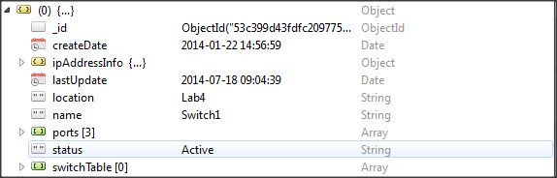Picture 2.105. Operator $addToSet – before update
Command to update:
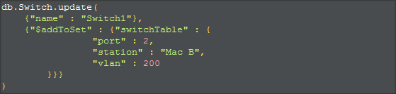
The result:
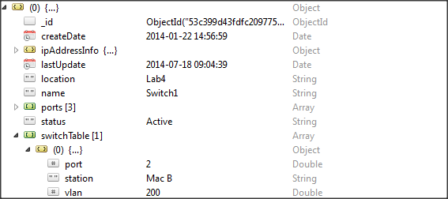Picture 2.106. Operator $addToSet – result of update

Using MongoTemplate:
Picture 2.107. Operator $addToSet using java
* Note: We can add multiple elements by using modifier $each. See modifier $each.

2.3 Remove operations
MongoDB use remove() method to remove documents.
Syntax:
db.collectionName.remove([{selection criteria}], single)
+ Selection criteria : is criteria to select document which is needed remove.
+ Single : only delete single document or delete all documents which pass criteria. Value is true or false. Default value is false.

2.3.1. Remove all documents
Criteria: no
Single: false
In Robomongo:
Use MongoTemplate:
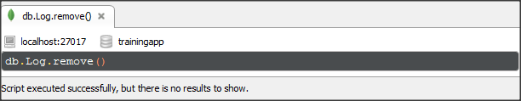Picture 2.108. Remove all documents
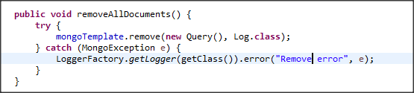Picture 2.109. Remove all documents using java
Use Repository:
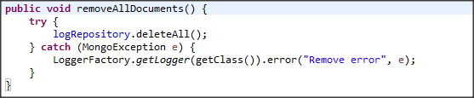Picture 2.110. Remove all documents using repository

2.3.2. Remove documents by criteria
Criteria: logType equal “Success”.
Single: no
In Robomongo:
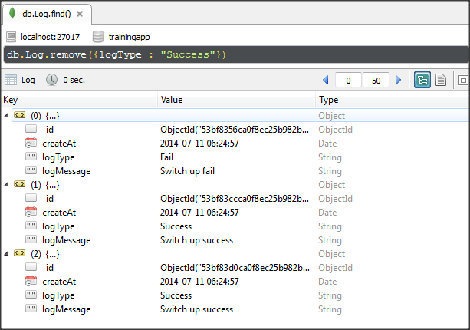Picture 2.111. Remove documents by criteria
The result:
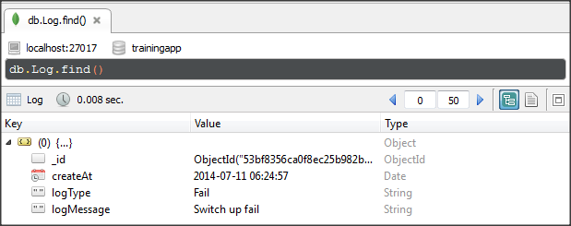Picture 2.112. The result after remove docuements
Use MongoTemplate:
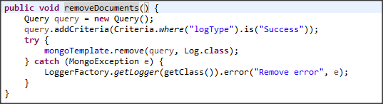Picture 2.113. Remove documents by criteria using java
Use Repository:
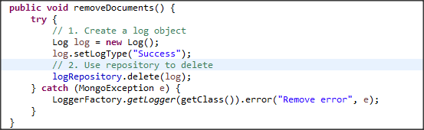Picture 2.114. Remove documents by criteria using repository

2.3.3. Remove single document with criteria
To remove single document, we can remove by _id field, or others which is an unique field. Beside, we also set single option in remove() method to remove single documents.
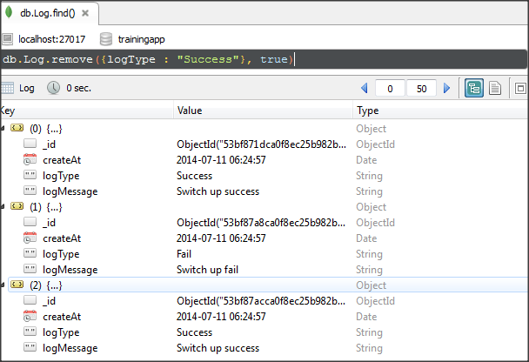Picture 2.115. Remove single document by criteria
The result:
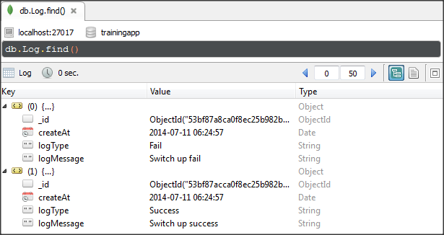Picture 2.116. The result of result single document with criteria

DBREFS
DBRefs are references from one document to another using the value of the first document’s _id field, collection name, and, optionally, its database name. By including these names, DBRefs allow documents located in multiple collections to be more easily linked with documents from a single collection.

Example:
Our database store information of devices in a collection Device. And each device has many ports. I want to save information of ports in other collection. So I use DBrefs to reference port collection and device collection.

Device collection:
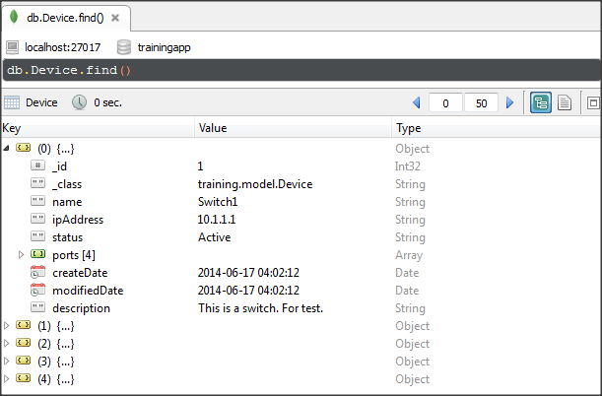Picture 3.1. Device collection
Port collection:
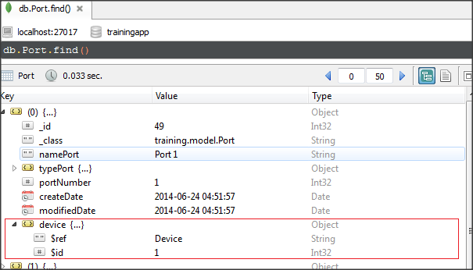Picture 3.2. Port collection

Each port document will has a field “device” additionally. This field will be used to reference to device which include this port.
Field “device” has 2 field:
+ $ref : is collection which is referenced.
+ $id : _id of document which is referenced.
* The order of fields in the DBRef matters, and you must use the above sequence when using a DBRef.

3.1 Query DBRefs
MongoDB don’t provide tools to use DBRefs. You must use drivers which provide helper method query for DBRefs. Spring Mongo data provide an easiest way to use DBRefs is @DBRef annotation. You need set @DBRef for proper field in model class. For example:
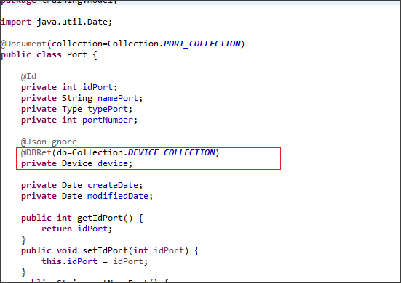Picture 3.3. Port model class
Then we use Port class for query. Information of referenced device will be gotten automatically. For example:
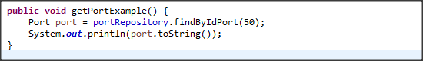
Result:
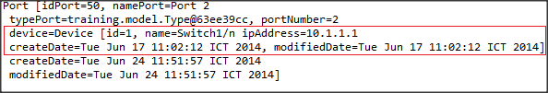

3.2 Restriction
DBRef is only a convention which tells driver to auto-load referenced documents. So our application will must perform addition queries.
Compare with embedded document:
- The storage overhead is smaller.
- The performance overhead is higher.
Because of DBRef is expensive for query. So it shouldn’t be used unless we work with big system that require scalability.

Appendix

MongoDB Operators

Query Operators
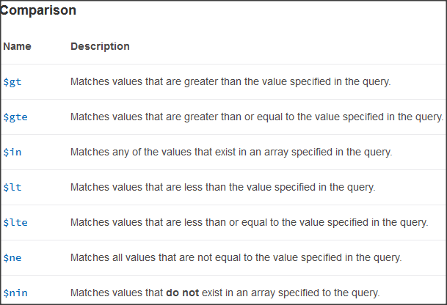
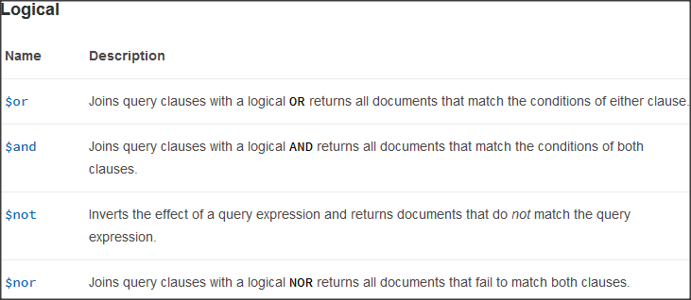
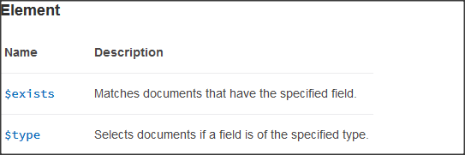
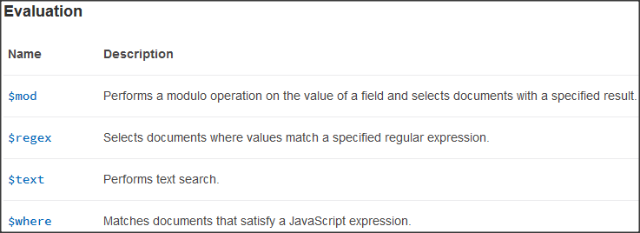
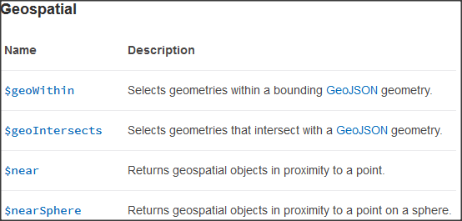

Projection Operators
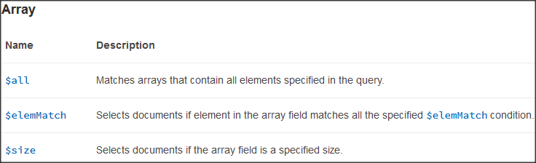
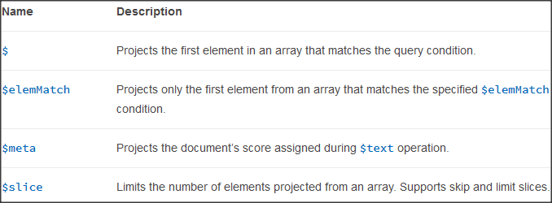

Update Opertors
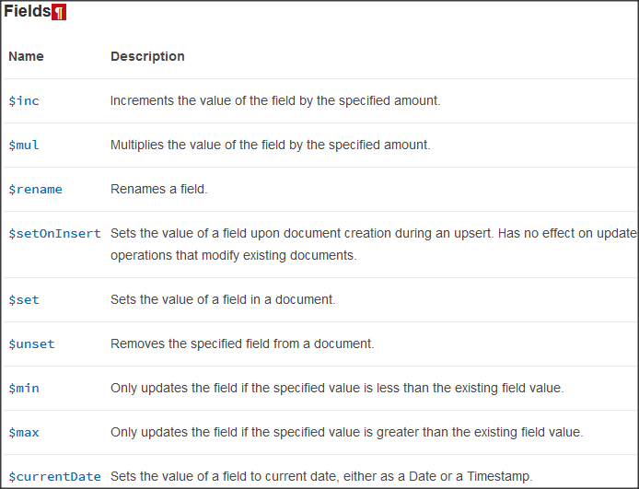
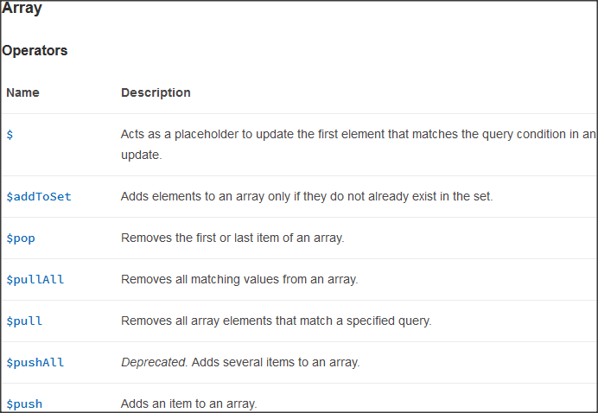
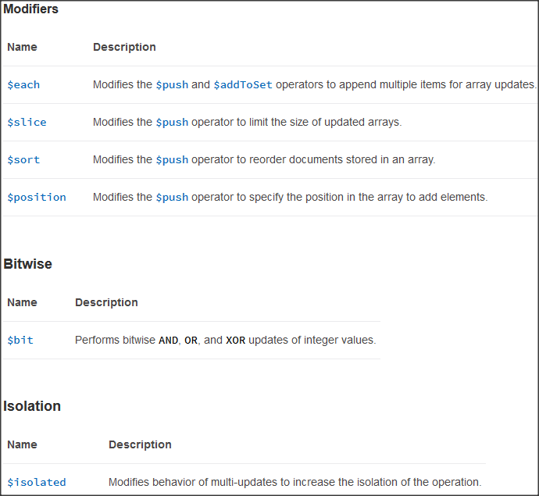

Types of data in MongoDB
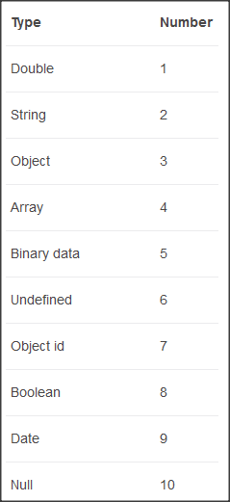
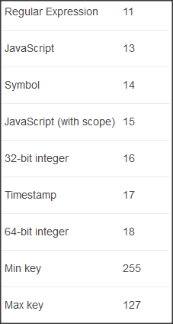

Collections in examples
- Switch collection:
- Log collection:
- Port collection:
- Device collection:

